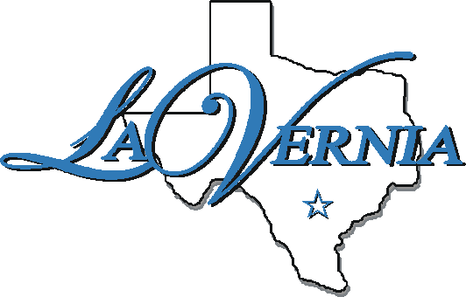
City of La Vernia

CITY COUNCIL & MUNICIPAL DEVELOPMENT DISTRICT
JOINT BUDGET WORKSHOP

City Council Chambers of La Vernia City Hall
102 E. Chihuahua Street, La Vernia, Texas 78121

July 28, 2020
5:30 p.m.

MINUTES

1. | Call to Order – President Jay Hennette called the meeting to order at 6:31 PM and declared a quorum. All members were present.
2. | Pledge of Allegiance and Invocation- Mayor Gregory gave the invocation and all in attendance recited the Texas Pledge and Pledge of Allegiance.
3. | Discussion/Action
 | A. | Discuss and consider action on the City of La Vernia and Municipal Development District 2020 - 2021 Fiscal Year budget.  City Administrator presented the City of La Vernia and MDD 2020-2021 proposed Fiscal Year budget. City Administrator made handouts to include budget works sheets and personnel salary sheets.
 | B. | Discussion on Capital Improvement Projects.  Mayor Gregory & City Administrator stated we will focus primarily on wastewater – plant off of River Rd., raceway and other items with possible plans to take over sewer plants in the future.
5. | Adjourn – Dianell Recker made a motion to adjourn the meeting, seconded by Eloi Cormier. All were in favor and meeting was adjourned at 7:44 PM.

_____________________________
Dianell Recker, Vice President

ATTEST:

_____________________________
Brittani Porter, City Secretary

